**DAILY ONLINE ACTIVITIES SUMMARY**

|  |  |  |  |  |  |  |  |
| --- | --- | --- | --- | --- | --- | --- | --- |
| **Date:** | | **21/05/2020** | | | | | |
| **Name of the Faculty** | | **Shilpa** | | | | | |
| **No. of Students Allotted for monitoring** | | | | | **19** | | |
| **Progress** | | | | | **Good** | | |
| **Whether collected report from all the allotted students** | | | | | **14 submitted** | | |
| **Online Test Summary** | | | | | | | |
| **Subject** |  | | | | | | |
| **Semester** |  | | | **Duration** | |  | |
| **No. of students Taken** | | |  | **Passing %** | |  | |
| **Certification Course Summary** | | | | | | | |
| **Course** | | **Visual Basic - Working with Classes, Scope and Namespaces - Revised** | | | | | |
| **Certificate Provider** | | **Alison** | | | **Duration** | | **2-3 Hours** |
| **Coding Challenges** | | | | | | | |
| **Problem Statement: - Write a simple applet java program to check whether the given number is armstrong number or not.** | | | | | | | |
| **Status: -** | | | | | | | |
| **Uploaded the report in Github** | | | | | **YES** | | |
| **If yes Repository name** | | | | | <https://github.com/shilpahassan/Daily-Report> | | |
| **Uploaded the report in slack** | | | | | **YES** | | |

Online Test Details: (Attach the snapshot and briefly write the report for the same)

Certification Course Details: (Attach the snapshot and briefly write the report for the same)

Coding Challenges Details: (Attach the snapshot and briefly write the report for the same)

**Certification Course Summary**

There are 3 modules in the certification course, I completed 2nd module.

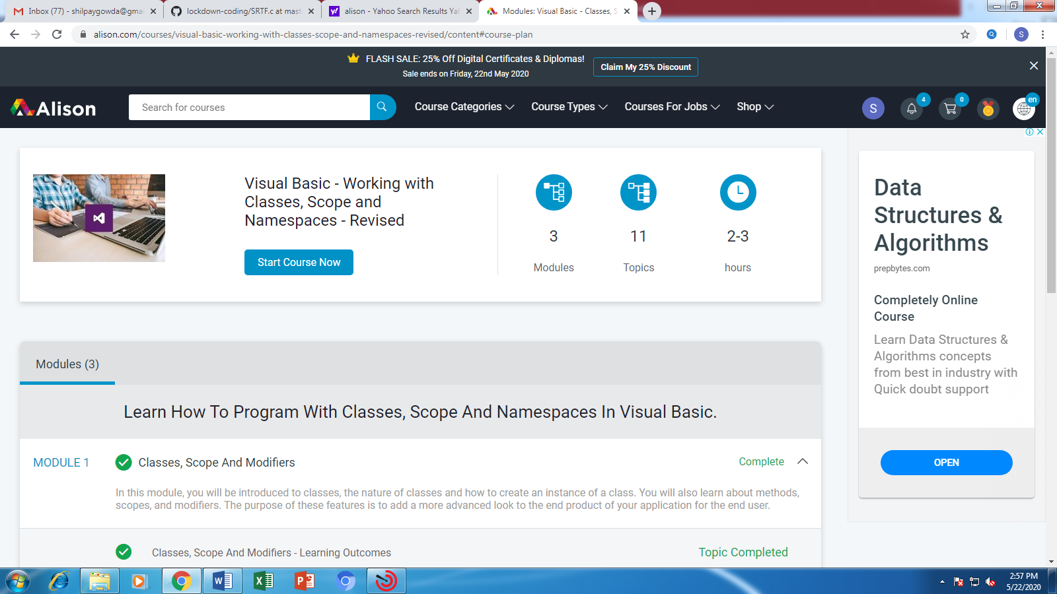

**Students Report:**

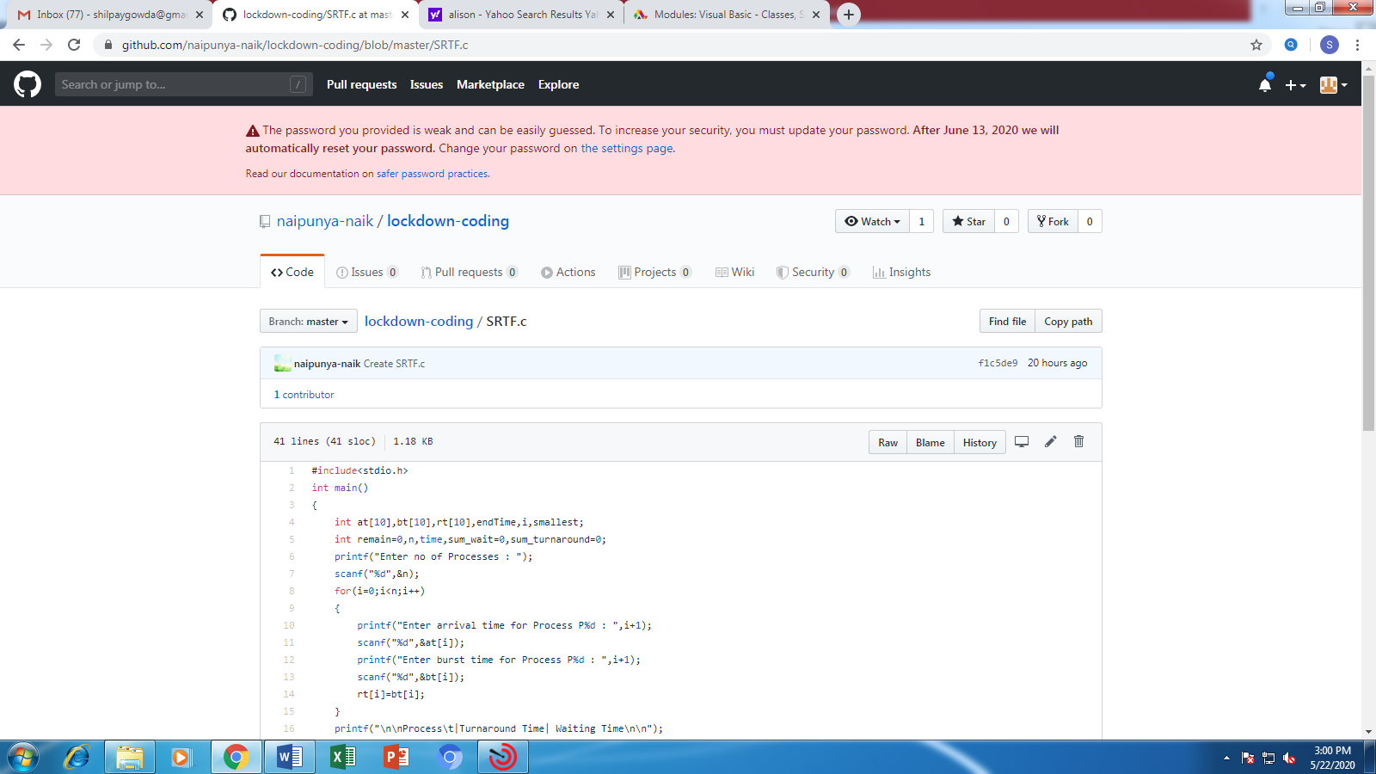

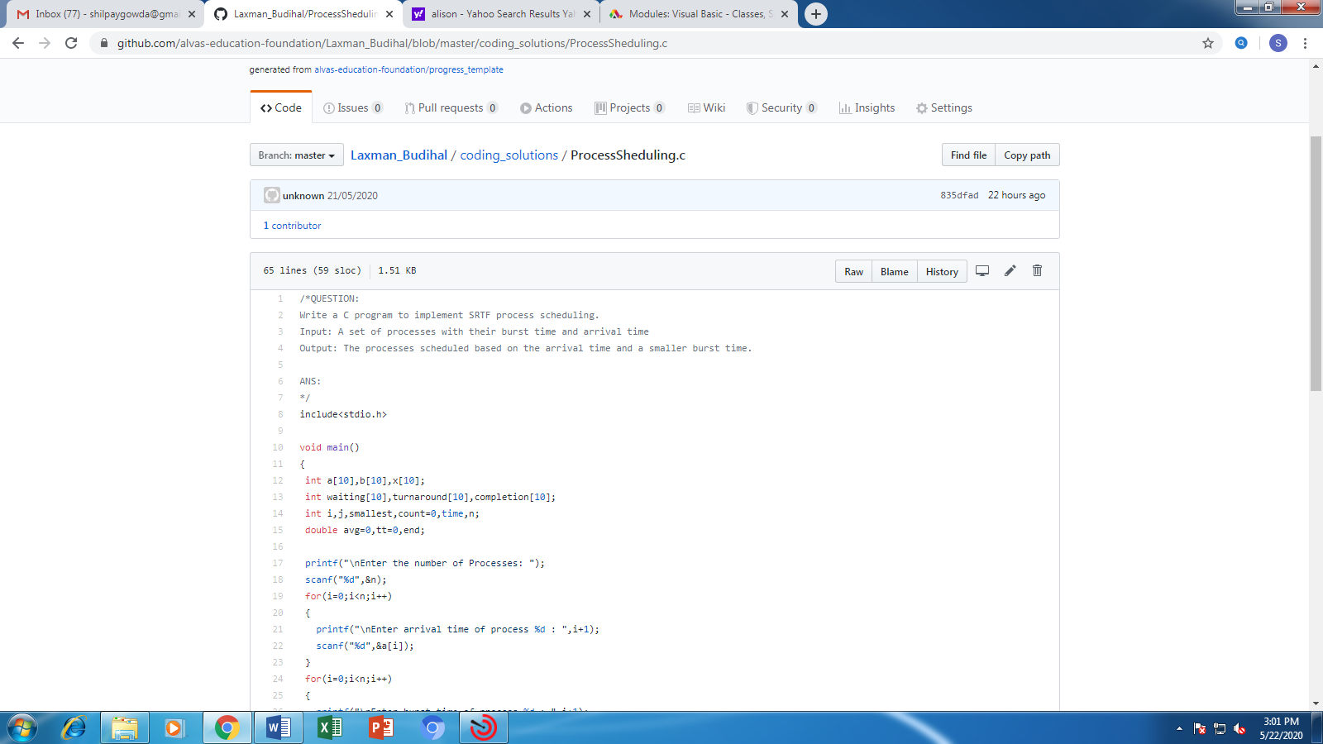

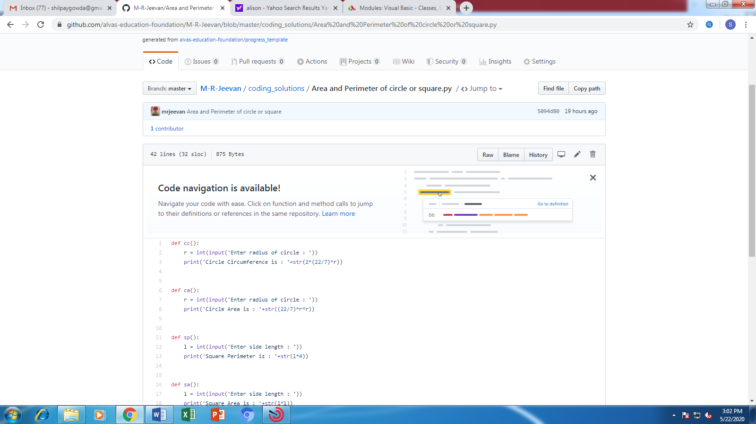

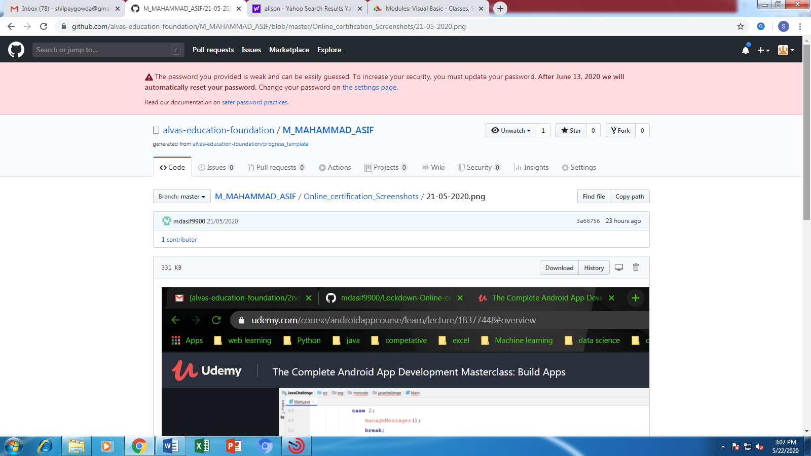

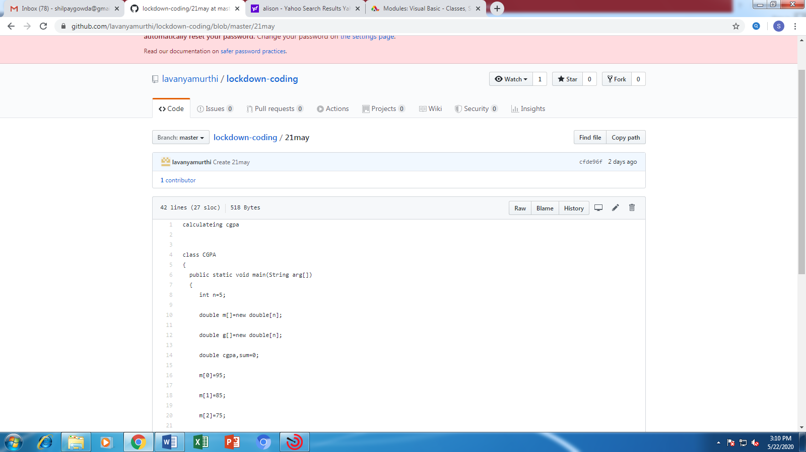

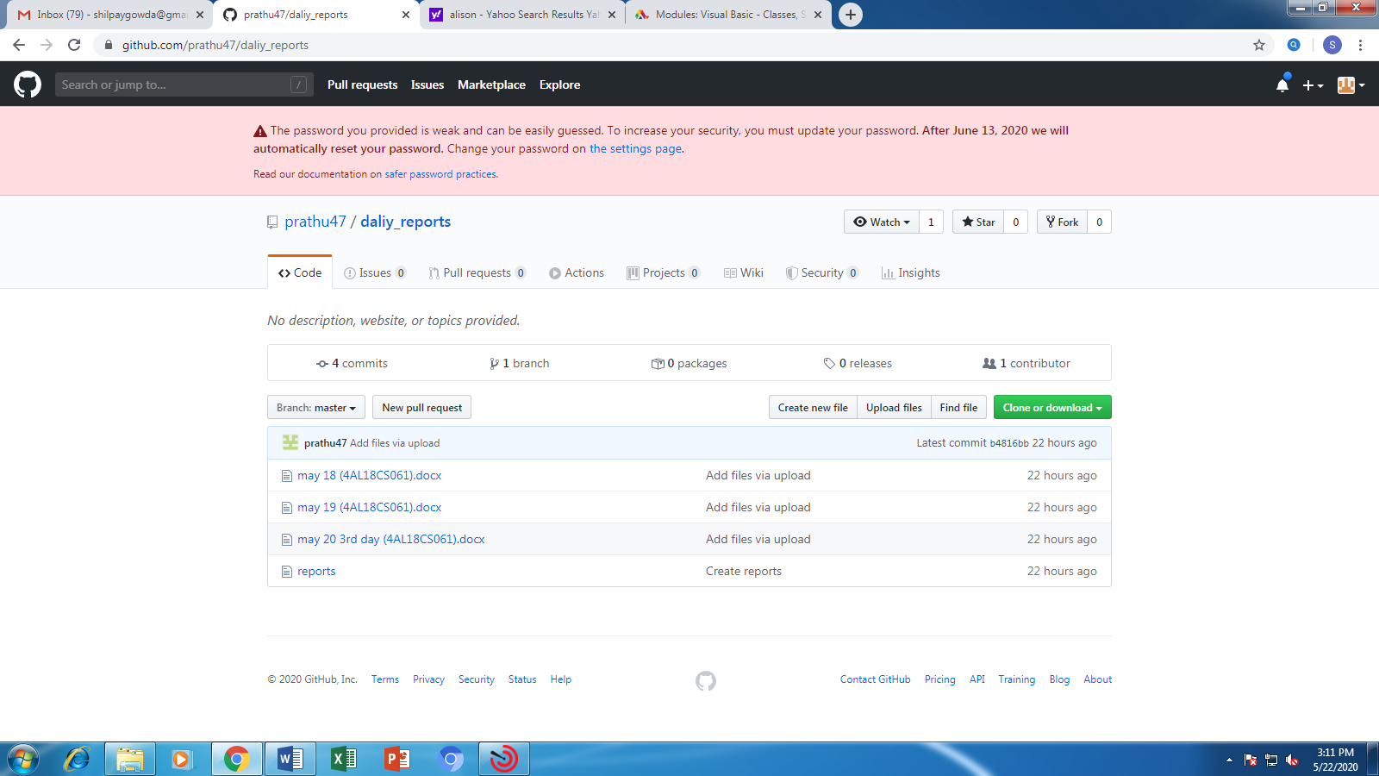

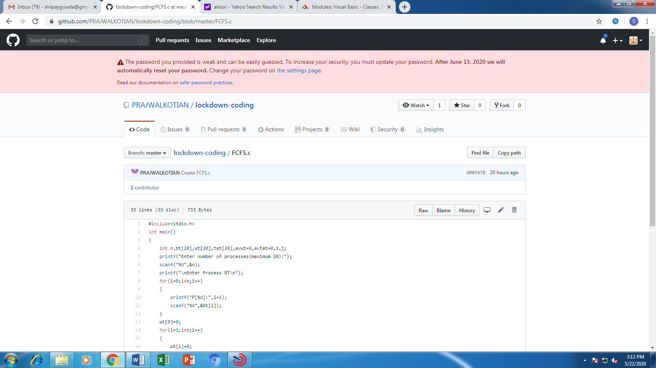

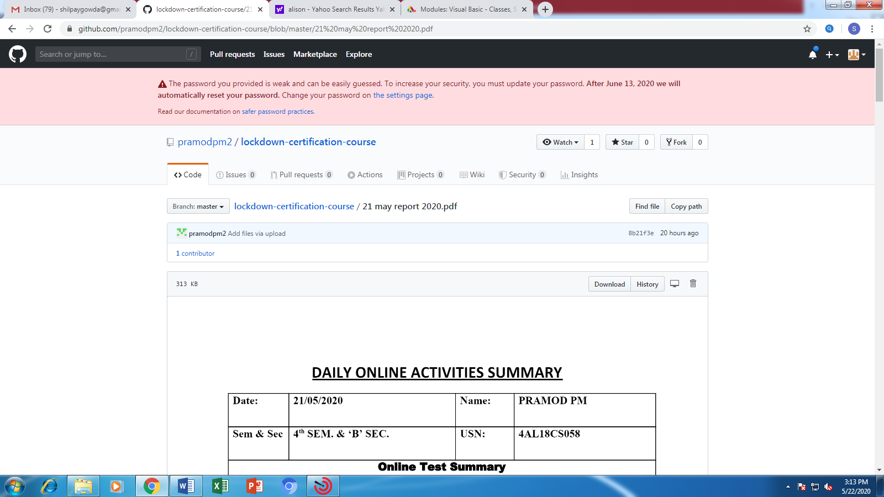

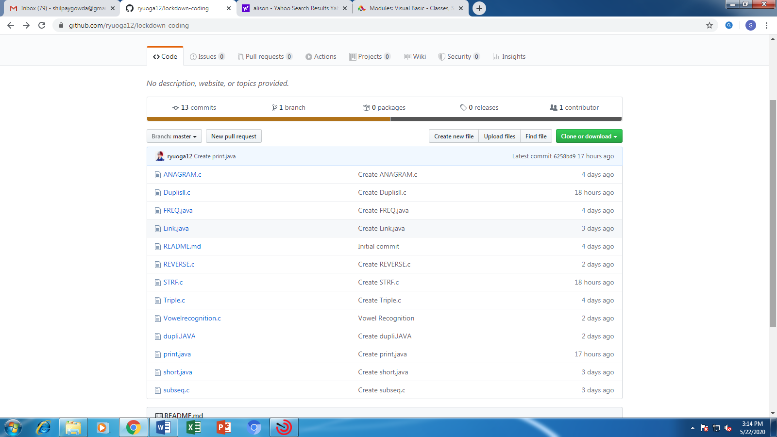

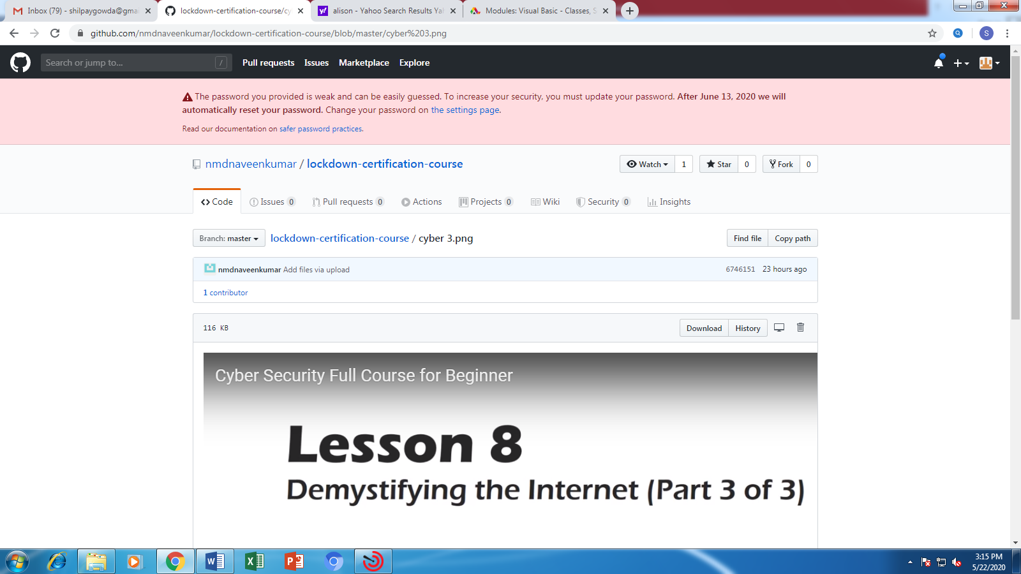

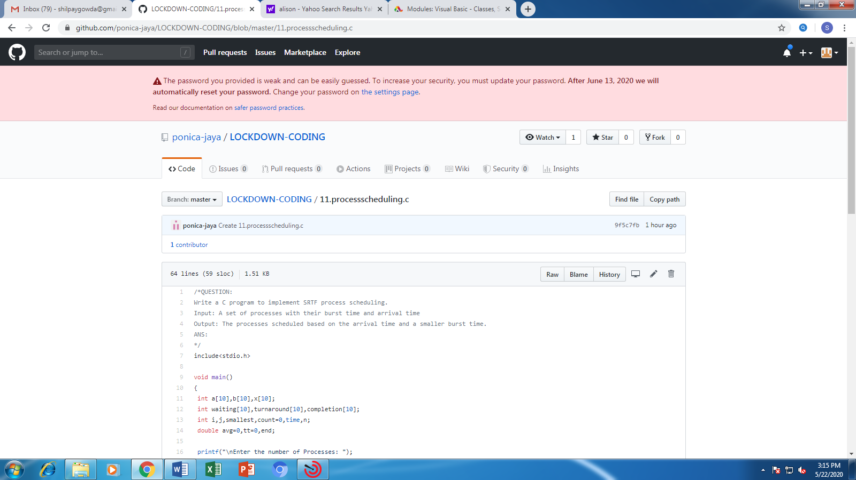

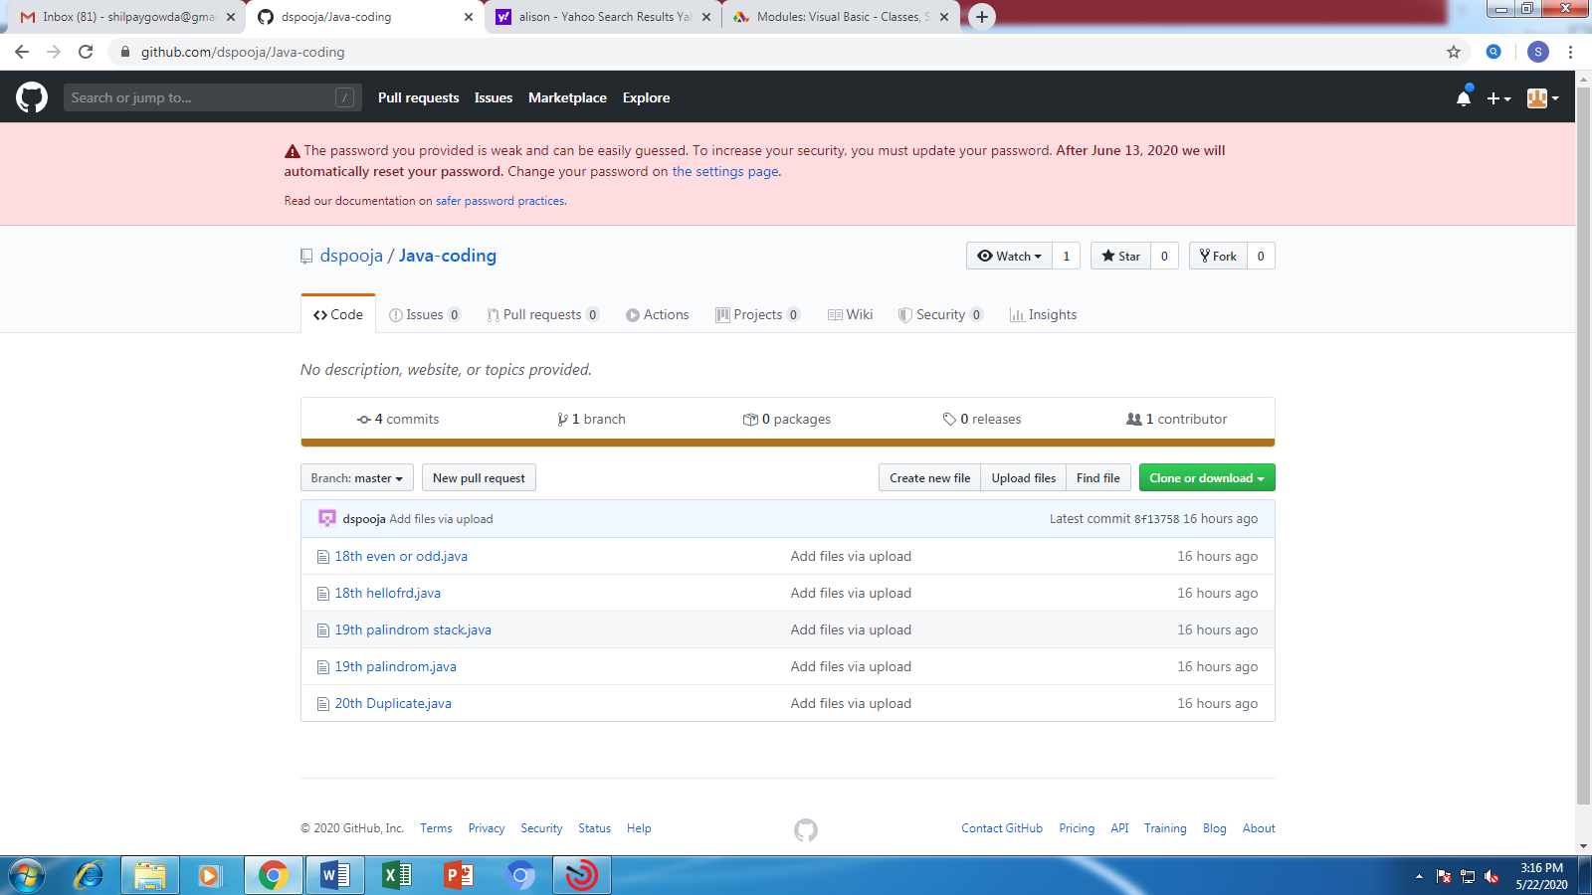

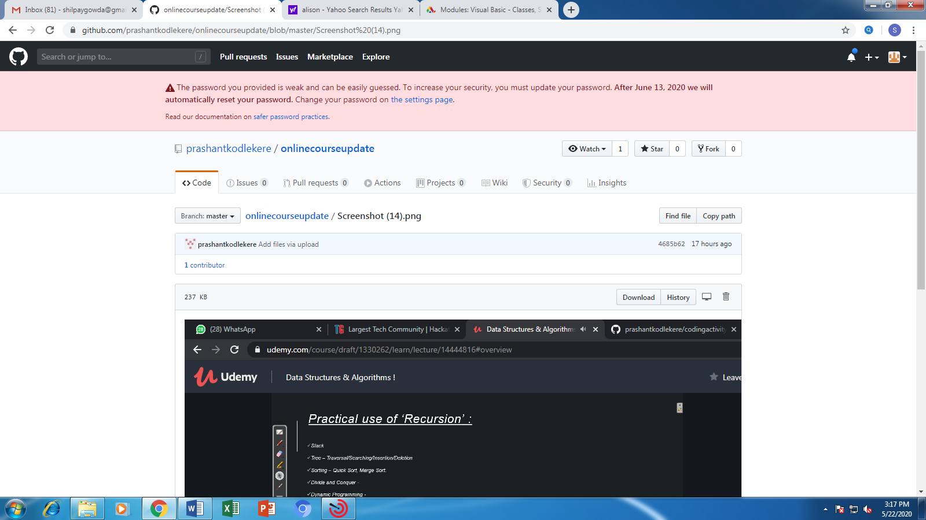

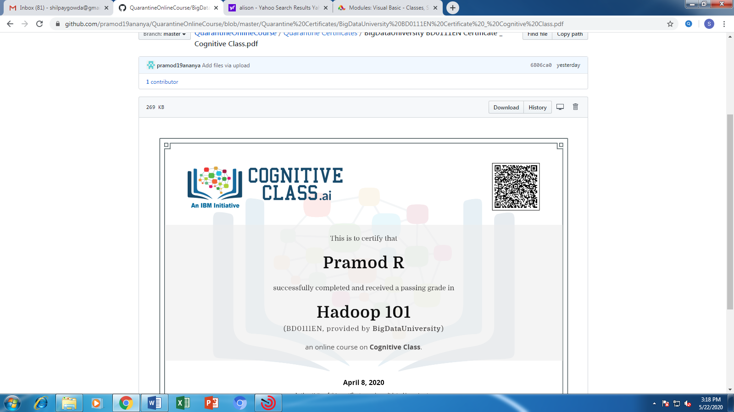

Coding Challenges Details

